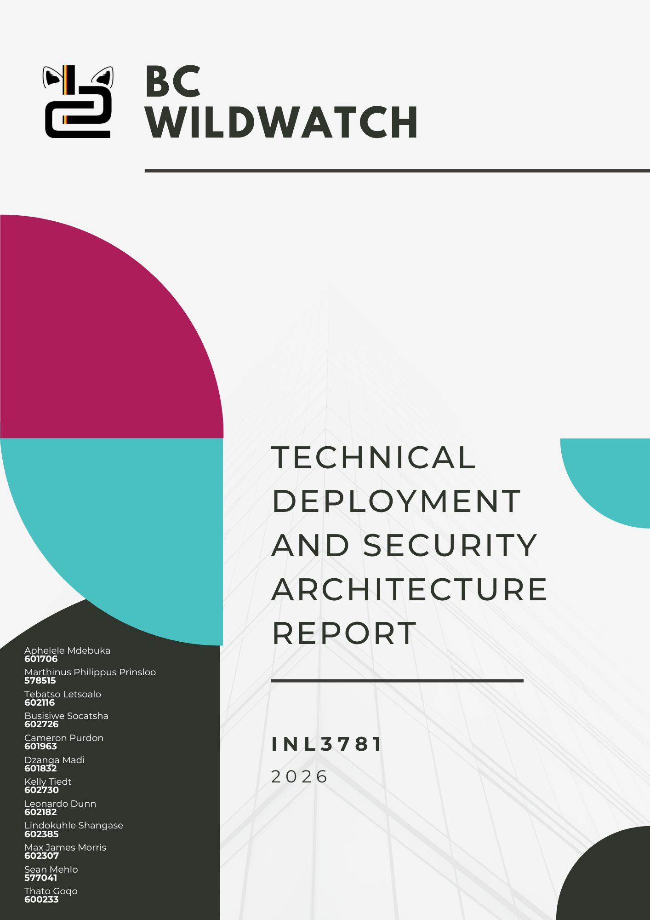

1. Executive Summary
This report outlines the architecture, deployment model, security framework, risk analysis, and governance structure of the BC WildWatch™ system. The project extends the prototype developed in INL201/2 into a production-ready web solution hosted publicly via GitHub Pages under a custom domain while enforcing institutional authentication through Microsoft 365 A3.
The system integrates a static web portal, Microsoft Entra ID authentication, Power Apps for incident reporting, SharePoint Online for data storage, Power Automate for workflow notifications, Power BI for analytics, and OpenAI API integration for safety guidance. The deployment demonstrates modern DevOps practices, secure identity management, and structured governance suitable for a real-world implementation.

2. Technology Selection Justification
The technology stack was selected based on four primary considerations: cost efficiency, compatibility with Microsoft 365 A3, deployment simplicity, and scalability.
The web portal is hosted using GitHub Pages. This platform provides free static hosting, native integration with Git version control, and automatic HTTPS security. The ability to deploy directly from repository branches supports continuous integration and controlled release workflows.
A custom domain was registered through GoDaddy to enhance professionalism and improve accessibility. DNS mapping connects the domain to GitHub infrastructure while allowing full domain management and branding.
Authentication is implemented using Microsoft Entra ID within the Microsoft 365 A3 tenant. This approach ensures that only institutional accounts can access protected system functionality. The use of OAuth 2.0 authentication standards ensures secure login flows and token-based session management.
The operational application layer is built within Microsoft Power Platform. Power Apps provides the user interface for incident reporting, SharePoint Online stores structured data, Power Automate manages alert workflows, and Power BI generates analytical dashboards. This ecosystem was selected due to its seamless integration within the Microsoft environment and its ability to support rapid development without extensive infrastructure management.
The OpenAI API was incorporated to provide AI-generated safety guidance. To protect credentials, API calls are mediated through a secure backend configuration rather than directly from client-side code.

3. Deployment Strategy
The deployment follows a structured DevOps model using Git-based version control and automated deployment.
Development occurs within feature branches where changes can be tested before integration. The master branch represents the production environment and is the only branch deployed publicly. All changes are merged into this branch through Pull Requests, ensuring that updates are reviewed before release.
Continuous Integration and Continuous Deployment (CI/CD) are implemented through GitHub Actions. When changes are merged into the production branch, the repository automatically builds and deploys the updated site to GitHub Pages. This automated workflow ensures consistent deployment and reduces manual configuration errors.
The custom domain is connected to the GitHub deployment through DNS configuration in GoDaddy. A-record and CNAME mapping direct traffic from the domain to the hosted GitHub Pages site. HTTPS encryption is automatically enforced, ensuring secure communication between users and the application.
The static web portal functions as the system entry point. After authentication through Microsoft Entra ID, users interact with embedded application components including the Power App reporting interface and administrative dashboards.

4. Risk Assessment
The deployment introduces several potential risks related to technical implementation, security exposure, and operational coordination.
Technical risks primarily relate to deployment stability. Incorrect configuration of CI/CD pipelines could prevent successful deployment of updates. This risk is mitigated through structured branching strategies and version control, which allow previous versions to be restored if needed.
DNS configuration errors could temporarily disrupt access to the application. To reduce this risk, DNS records were validated and propagation was confirmed prior to enabling the production domain.
Authentication misconfiguration could allow unauthorized access. This risk is mitigated by restricting login access to the institutional tenant within Microsoft Entra ID and ensuring that redirect URIs are limited to the official domain.
Security risks include exposure of API credentials or unauthorized data access. These risks are mitigated through backend storage of API keys, strict SharePoint permissions, and enforcement of encrypted HTTPS communication.
Operational risks involve project coordination and version control management. Without clear responsibility allocation, deployment delays or configuration conflicts may occur. This risk is addressed through defined governance and task allocation.

5. Data Security Plan
Security is implemented across identity management, network communication, data storage, and API integration.
User authentication is managed through Microsoft Entra ID. Only authenticated accounts within the institutional tenant are allowed access to protected system features. Token-based authentication ensures that user sessions are securely managed.
All communication with the deployed application is encrypted using HTTPS with TLS encryption. This prevents interception of authentication credentials or data during transmission.
Incident report data is stored within SharePoint Online, which provides built-in security features including role-based access control, version history, and administrative oversight. Editing permissions are restricted to authorized users to maintain data integrity.
OpenAI API integration follows a secure proxy model. API keys are stored within backend environment variables and are never exposed in the client interface. Requests are routed through a controlled endpoint to maintain security.
Version control and backup capabilities are supported by both SharePoint version history and the GitHub repository history. These mechanisms allow recovery of previous versions if data corruption or accidental modification occurs.

6. Governance and Task Allocation
Successful deployment required structured responsibility allocation to ensure accountability and coordination among team members.
The Project Lead holds overall accountability for project delivery and ensures alignment with module requirements. The DevOps Lead manages repository configuration, CI/CD implementation, and production deployment.
The Security Lead is responsible for configuring authentication, enforcing access control, and securing API integrations. The Application Developer manages Power App functionality and integration within the web portal.
The Data Analyst is responsible for dashboard creation and validation of analytical outputs within Power BI. Documentation responsibilities include maintaining technical documentation and ensuring compliance with submission standards.
To formalize responsibility allocation, the project applied a RACI governance framework.

Project Responsibility Matrix (RACI Framework)

Table 1: RACI matrix showing responsibility allocation for the BC WildWatch deployment project
Task / Deliverable | Marthinus P. Prinsloo (Team Lead) | Aphelele Mdebuka (Team Lead) | Tebatso Letsoalo | Busisiwe Socatsha | Cameron Purdon | Dzanga Madi | Kelly Tiedt | Leonardo Dunn | Lindokuhle Shangase | Max J. Morris | Sean Mehlo | Tato Goqo
Public Web Deployment (GitHub Pages & Workflow) | R/A | C | I | I | I | I | I | I | I | I | I | I
HTML Webpage Development | C | R/A | I | I | I | I | I | I | I | I | I | I
Microsoft 365 A3 Authentication Integration | A | A | I | I | I | I | I | I | I | I | I | I
Secure Data Access Layer (SharePoint) | C | A | R | I | I | I | I | I | I | I | I | I
Power Apps Integration into Webpage | C | R/A | C | I | I | I | I | I | I | I | I | I
Deployment Strategy Decision | R/A | C | C | I | I | I | I | I | I | I | I | I
Deployment Documentation (Technical Report) | C | R/A | I | I | I | I | I | I | I | I | I | I
RACI Matrix Development | C | R/A | I | I | I | I | I | I | I | I | I | I
Architecture Diagram | C | A | R | I | I | I | I | I | I | I | I | I
QR Code Implementation | R/A | C | I | I | I | I | I | I | I | I | I | I

